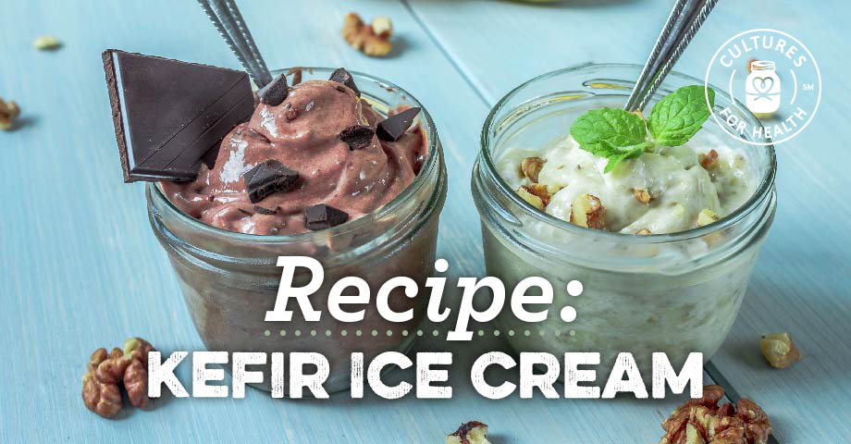

One of the most popular ways to use extra kefir! Make it with vanilla, or try one of the variations listed below.

Ingredients:
- 2 eggs
- ¾ cup organic sugar (or 5 tablespoons raw honey)
- 2 cups milk kefir
- 1 cup heavy cream
- 2 tsp. vanilla extract
- Beat eggs well; beat in sugar. Start with a conservative amount of sweetener and add in small increments to taste; keep in mind that the finished ice cream will be slightly less sweet than the kefir mixture before it’s frozen
- Blend in milk kefir, heavy cream and vanilla.
- Transfer to an ice cream maker and follow manufacturer's instructions..

Flavor Variations:
- Add ⅔ cup organic cocoa powder. Increase the amount of sweetener to taste.
- Add ½ to 1 cup crushed strawberries.
- Decrease the amount of vanilla extract and add 1-3 teaspoons mint extract. If desired, add organic dark chocolate chips or a 3-ounce organic dark chocolate bar, chopped.
- Turtle: Add toasted organic unsweetened coconut flakes, toasted organic pecans, and organic dark chocolate chips. Drizzle with raw honey or homemade caramel sauce.

Milk and Honey Homestead
Offering raw milk shares from grass-fed cows. Call Tami @ 970-417-7506

