Pamper Your Face with a Kefir Mask

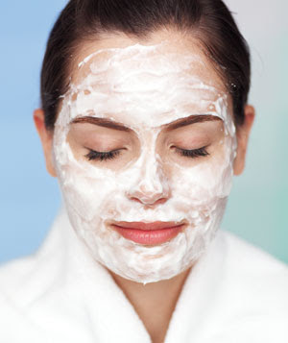
Kefir is wonderfully beneficial for your skin; it naturally contains Alpha Hydroxy Acid (AHA) that is said to reduce wrinkles or the signs of aging, and improve the overall look and feel of the skin.
In kefir, alpha hydroxy acid is in the form of lactic acid.
Lactic acid naturally harmonizes with the slight acidity of our skin and hair. The lactic acid in kefir softly dissolves the lipids that hold old skin cells together and helps to remove dead skin particles so that new skin can emerge into new radiance. Other miracles of alpha hydroxy acid found in kefir include reducing the appearance of wrinkles and scar tissue, and fading aging spots and freckles.
You can put kefir alone on you face for a therapeutic mask or you can follow this recipe:
Kefir Honey Oatmeal Mask
½ cup oats (may pulse in blender for finer texture)
¾ cup of kefir
2tbsp of warm liquid honey
Mix kefir and oatmeal and refrigerate for ten hours. Add the honey and mix well. Apply the mask and leave on for twenty minutes while you enjoy a kefir smoothy.
Rinse well and apply a moisturizer to the face. This is a great mask for oily skin.
Milk and Honey Homestead
Offering raw milk shares from grass-fed cows
Call Tami @ 970-417-7506

