Blue Cheese and Walnut Kefir Dip

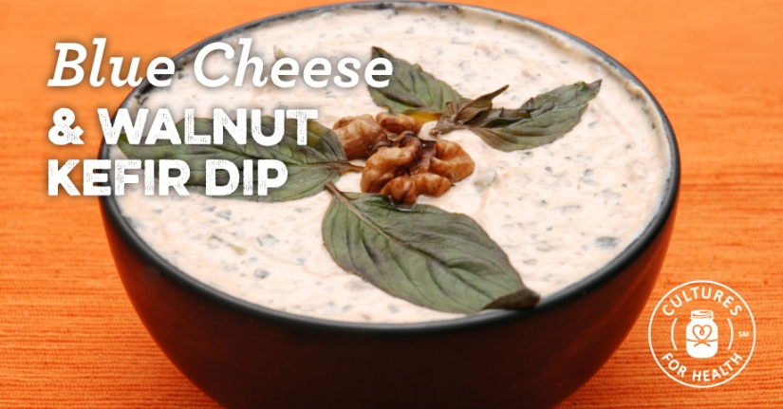
Blue cheese and toasted walnuts are complemented by the creamy tang of milk kefir. Serve with a selection of crisp vegetables and crackers for the perfect snack.

2 cups strained kefir (consistency of sour cream or slightly thicker)
4-ounces blue cheese, crumbled
1/2 cup walnuts, toasted and finely chopped
Sea salt and freshly ground black pepper to taste
- Combine all the ingredients and mix well.
- Cover and refrigerate for several hours prior to serving, to allow the flavors to meld.

Milk Kefir Vinaigrette

Liven up your everyday vinaigrette with creamy milk kefir, for a dressing that clings better to salad leaves and contains probiotics, too!
- 1/4 cup milk kefir
- 1/4 cup apple cider vinegar
- 1/2 cup extra virgin olive oil
- 1 garlic clove, minced
- 1 tsp. Dijon mustard
- 1 tsp. honey
- Salt and pepper to taste
- Combine all ingredients in a pint-sized canning jar.
- Put a lid on tight and shake well until emulsified.
- Use on your favorite salad and keep in the refrigerator for up to a week for subsequent salads.

